Introduction to Signal and Image Processing

Lab 2
In this assignment, the job was to use a chroma key over the following two images:
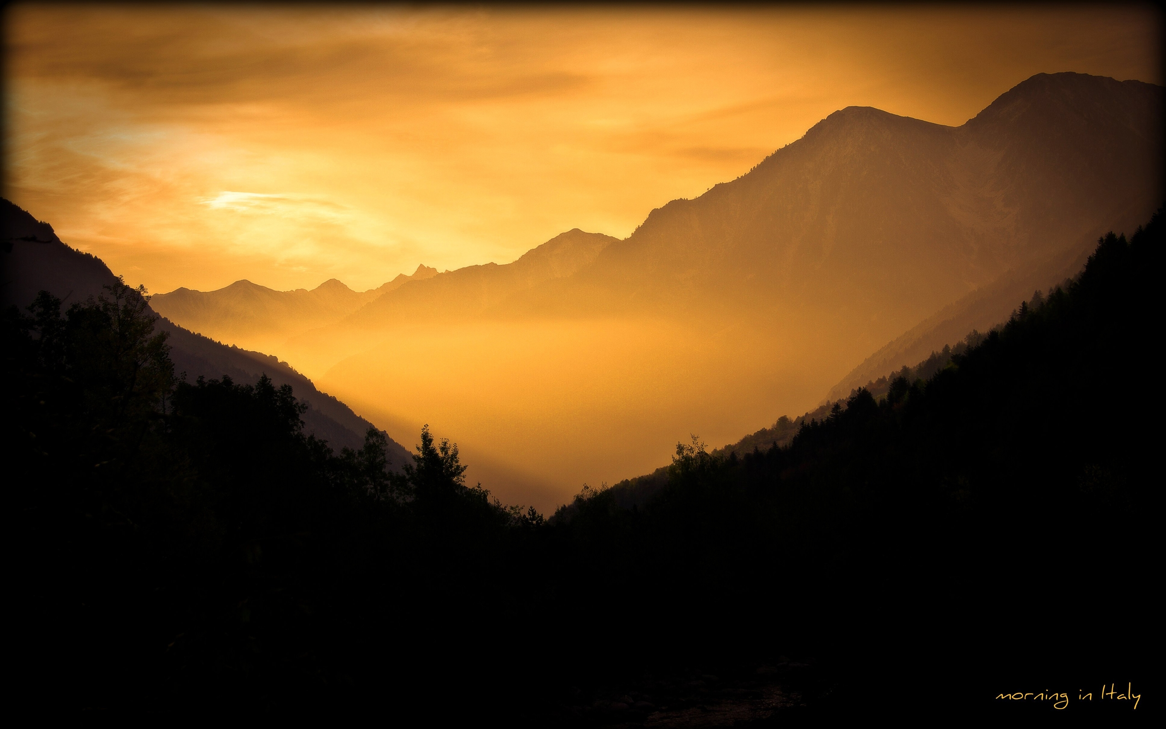
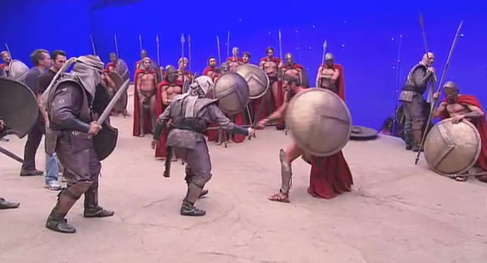

The Chroma Key
To setup the chroma key for image two, I used all three channels. The biggest three problems with this pictures:
1. The staves appear with a blue shade and are very thin, so they are very hard to extract.
2. The blue screen isn't always in the same shade of blue. For example in the top left it is darker than in the rest of the picture, which makes the range for the acceptable values for the filters smaller.
3. The white dots in the wall on the screen.

The first problem I wasn't able to fully solve, but using all three color channels seemed to give me a bit better picture. Problem three I could solve with a bit of blurring in the filters. This removed most of the dots in the picture.
As seen in the resulting picture, there are still three problems left however:
1. There are still some small blue dots left in the bluescreen which I couldn't remove.
2. The staves aren't fully displayed
3. There is a slight blue border between the two images. I guess this is because the blue around objects isn't in the same shade, but slightly lighter. No matter what values I set for the filters I couldn't get rid of them. If you have an idea how to remove them, I would love to hear it!

Making the Images Similar
I used two methods to make the background image similar to the foreground image.
One technique used is the grayworld approach. Here I use the averages from the foreground image and apply them to the background image to make the hues similar.

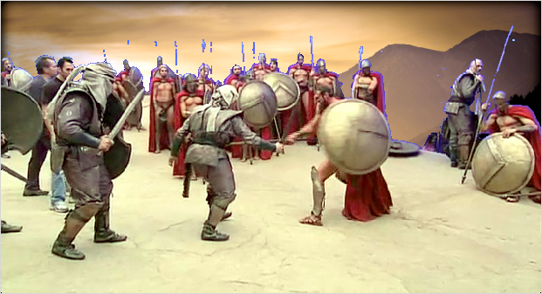
Secondly, since the histograms are very different, I use contrast stretching on both images. Since this distributes the intensities over the image, both images end up with comparable results.

